Bare feet, hot sand, cool water.
- a) Recall the first law of thermodynamics.

b) Show how the ideas of energy, heat, thermal energy, temperature, specific heat capacity are related using a visual organizer or annotated diagram.

- Use your ideas about specific heat capacity and the information in Table 1 p.2 292 in Nelson Chem 12 to explain why sand feels hotter than the water at the beach. Draw in the sun somewhere.

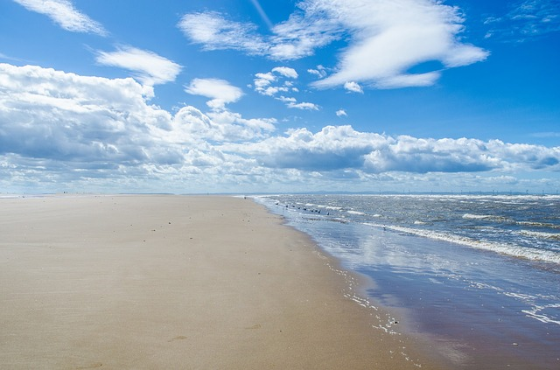
- Apply the first law of thermodynamics and your ideas about thermal energy and exothermic and endothermic chemical reactions to a chemical system which involves the reaction of two dilute solutions. Show how a styrofoam cup calorimeter can be used to measure energy changes during a chemical reaction.
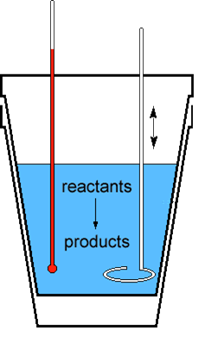
- When HCl_{(aq)} is mixed with NaOH_{(aq)}, thermal energy is released into the environment – the reaction is exothermic. If we mix very dilute solutions of these compounds, the heat energy change resulting from the reaction can be inferred from the temperature change.
- What does the amount of temperature change of the water in the calorimeter during the reaction depend on? Write the statements as proportionality statements. Combine the proportionality statements into an equation.

- a) Reexpress the idea that the change in a variable can be found by subtracting its initial value from its initial value. | b) What is the significance of a negative value of q in the equation q = mcΔT?

- The temperature of a calorimeter containing 100mL of a dilute solution of hydrochloric acid at 22ºC increases to 23.2ºC when 150mL of a dilute solution of sodium hydroxide at 22ºC is added to it. Wha…?
- Where does the “extra” energy come from? How does this situation not break the 1st LoCoE?

- What amount of thermal energy is released by the system?

- Add the ideas of enthalpy and enthalpy change to your visual organizer from 1b).

- Determine the maximum temperature of a calorimeter containing 650 mL of water at 22ºC after 50.0g of aluminum at 35ºC is added.
- The laws of thermodynamics state that heat energy can only be transferred from an object that is ___________________ to the one that is __________________.
- The energy lost by the aluminum should be gained by the __________________.
- There is no such thing as “cold”, actually.
Assumptions | Picture
Notes | Calculations

- How much thermal energy is required to increase the temperature of Subang’s 5.0E7 L lake by 1ºC?
- Why will that amount of sunlight energy not actually heat the lake up by 1ºC? | - Given sufficient insulation to close the system, what mass of gold at 1000ºC would raise the temperature of the lake by 1ºC?

- What ideas would you highlight on these four pages?

