Malaysia and energy in pictures
- Find current costs to purchase ethanol and octane, or gasoline. Determine the energy released in the combustion of each fuel. Compare the efficiency of each fuel in kJ/(RM of production costs) of ethanol and octane.

- Check out these images! Discuss with colleagues, think, and write. How do they connect? What story do they tell? What do you see happening here? Predict the future!

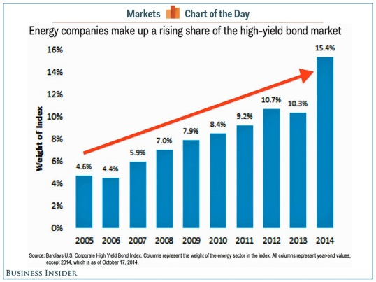
http://www.businessinsider.my/energy-companies-making-up-high-yield-bonds-2014-10/#.VFiQXjSUeSo

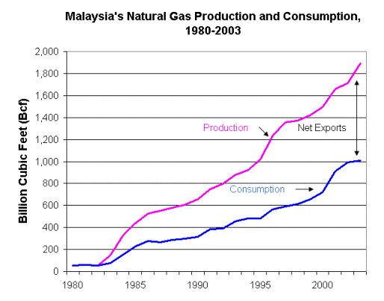
http://wn.com/s/malaysiaenergy_old1/

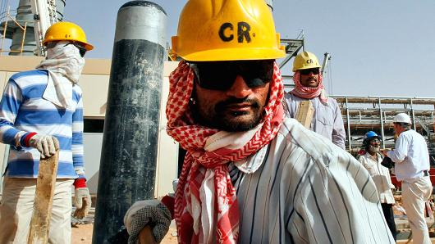
http://www.cnbc.com/id/102152020

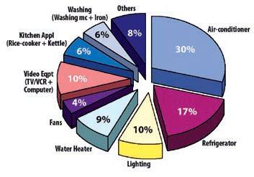
http://www.greentechmedia.com/articles/read/stat-of-the-week-47-percent

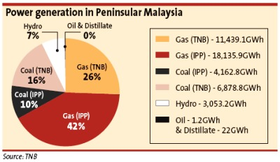
http://www.thestar.com.my/Story/?file=%2F2009%2F7%2F11%2Fbusiness%2F4279644

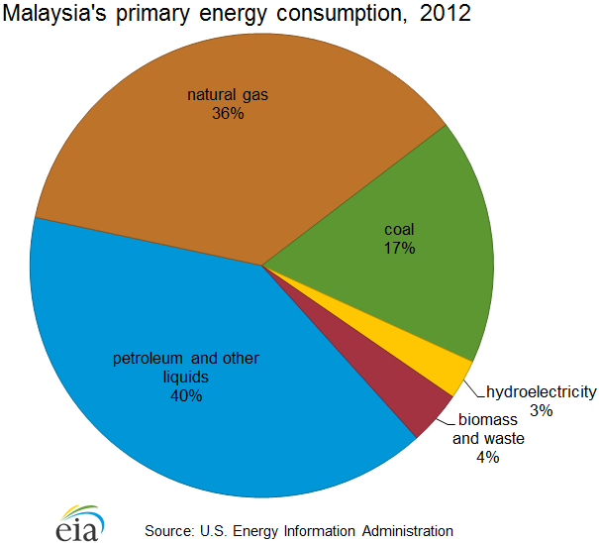
http://www.eia.gov/countries/cab.cfm?fips=my

- https://www.google.com.my/webhp?sourceid=chrome-instant&ion=1&espv=2&ie=UTF-8#safe=off&q=energy%20use%20in%20Malaysia
- https://www.google.com.my/publicdata/explore?ds=d5bncppjof8f9_&met_y=eg_use_pcap_kg_oe&idim=country:MYS:IDN:THA&hl=en&dl=en#!ctype=l&strail=false&bcs=d&nselm=h&met_y=eg_use_pcap_kg_oe&scale_y=lin&ind_y=false&rdim=region&idim=country:MYS:IDN:THA&ifdim=region&hl=en_US&dl=en&ind=false

- Ask some questions. Here are some of mine to start the discussion.
- How important are fossil fuel production and consumption in Malaysia and SE Asia? What are some potential issues in that field just now? in the next years? What are some effects of “tumbling oil prices” to Malaysia’s economy, to exports, and to energy use? How will falling oil prices affect energy companies’ ability to raise money and to manage their debt?

