SCH4U - Organic Chemistry test
- a) Identify the organic compounds from those below.

b) How did you identify the organic compounds above? What idea did you use?

- a) Which of these three compounds is likely to be the most soluble in water?

b) Explain your reasoning. How did you make your decision?
- Examine the graph of boiling points vs chain length in carboxylic acids and alkanes.
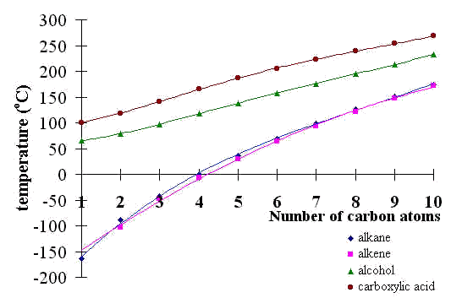
http://www.chemistryrules.me.uk/junior/organic_b_pts.gif
- Interpret the graph. What does it say?

- Why does the boiling point of the ____________________ increase with _______________?

- Why might a _______________________ have a higher boiling point than the __________________________ of the same chain length?

- Write balanced chemical equations using structural models to give an example of reactions that fit the details in column 1. Name all compounds.
Reaction details | Balanced chemical equation (using structural formulae)

- Name the following structures.

